

Face Recognition

*Ninestars Information Technologies Ltd*

January 2018

Contents

1 Introduction 1

1.1 SpeechBot 1

2 Tools 1

2.1.1 Pre-configuration and Installation Process 1

# Introduction

The document describes the code location, scripts and how they are run for the Face Recognition.

## Face Recognition

(NA)

# Tools



## GitLab Repository

RDCrew/face-recognition.git

## Pull Command

git clone [git@gitlab.ninestars.in:RDCrew/face-recognition.git](mailto:git@gitlab.ninestars.in:RDCrew/face-recognition.git)

Two Folders are created after git operation.

Backend Folder: This folder contains all the backend scripts. It must be run on GPU server.

Face_rec Folder: This folder contains the front end application and it must run on the client machine.

## Pre-configuration and Installation Process in Antek Server (Backend)

* Software Required in Backend machine (backend server : 192.168.12.39)
* OS version - Ubuntu-16.04
* Python 2.7
* Installation command for python pip module

**sudo apt-get install python-pip**

**Software dependencies:**

**There is no specified document provided to install the library dependencies.**

* List of python modules required

**pip install backports.shutil-get-terminal-size==1.0.0**

**pip install beautifulsoup4==4.5.1**

**pip install cycler==0.10.0**

**pip install Cython==0.24.1**

**pip install decorator==4.0.10**

**pip install doc2text==0.2.4**

**pip install enum34==1.1.6**

**pip install future==0.15.2**

**pip install ipython==5.1.0**

**pip install ipython-genutils==0.1.0**

**pip install levenshtein==0.0.0**

**pip install matplotlib==1.5.3**

**pip install mime==0.1.0**

**pip install numpy==1.11.1**

**pip install pathlib2==2.1.0**

**pip install pexpect==4.2.1**

**pip install pickleshare==0.7.4**

**pip install Pillow==3.3.1**

**pip install prompt-toolkit==1.0.7**

**pip install ptyprocess==0.5.1**

**pip install Pygments==2.1.3**

**pip install pyocr==0.4.1**

**pip install pyparsing==2.1.9**

**pip install PyPDF2==1.26.0**

**pip install pytesseract==0.1.6**

**pip install python-dateutil==2.5.3**

**pip install python-Levenshtein==0.12.0**

**pip install pytz==2016.6.1**

**pip install requests==2.11.1**

**pip install scipy==0.18.0**

**pip install simplegeneric==0.8.1**

**pip install six==1.10.0**

**pip install tesserocr==2.1.2**

**pip install traitlets==4.3.0**

**pip install wcwidth==0.1.7**

**pip install xmltodict==0.10.2**

How to Create the Virtualenvironment and install all the required python modules;

pip install virtualenv

virtualenv environment_name

source environment_name/bin/activate

To install the required libraries in this environment run the below command

pip install module_name

* Steps to install
* Go to the path mentioned below.

**cd /home/vinoo/face-recognition**

* Run the commands given below.

**source /home/ashtosh/Tools/virtualenvs/tensorflow/bin/activate**

* The command terminal is given below.

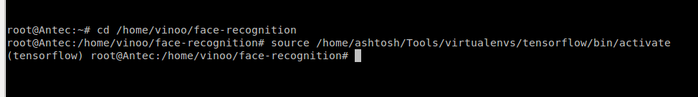

* Run the command given below in the command terminal

**CUDA_VISIBLE_DEVICES=2 python jars.py runserver -t 0.0.0.0**

* The command terminal after entering new command is given below

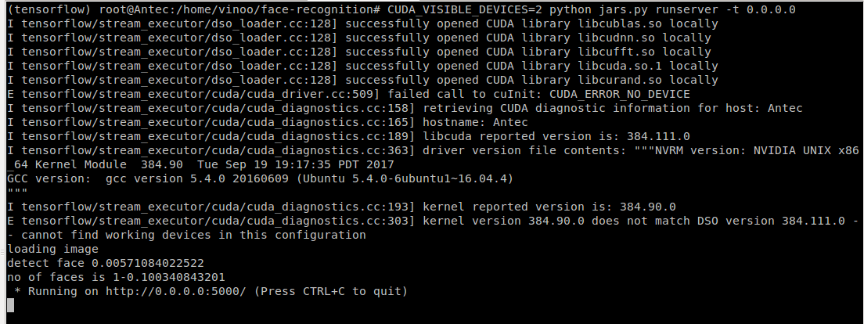

## Pre-configuration and Installation Process in Antek Server (Frontend)

* Software Required in Frontend machine
* OS version - Ubuntu-16.04
* Python 2.7
* Pull Command

**cd <gitrepository in local system>/face_rec**

Run the server

**node server.js**

## Steps to enroll for face recognition in URL

* Go to <http://localhost:8084/myapp/>
* Log in with any User name and Password

**Note**: Validation Process is not yet completed. Work In Progress.

* Click on the arrow mark on the top-left hand side
* Click Face Recognition
* FaceEnroll

Register the Face on to the server.

* FaceLookup

Search the name of the person based on the image.

* User Interface of Face Recognition website is given below.

